**One Page Abstract**

**IoT Based Safety, Monitoring and Alerting system for Mines**

Project Group: B3 G1

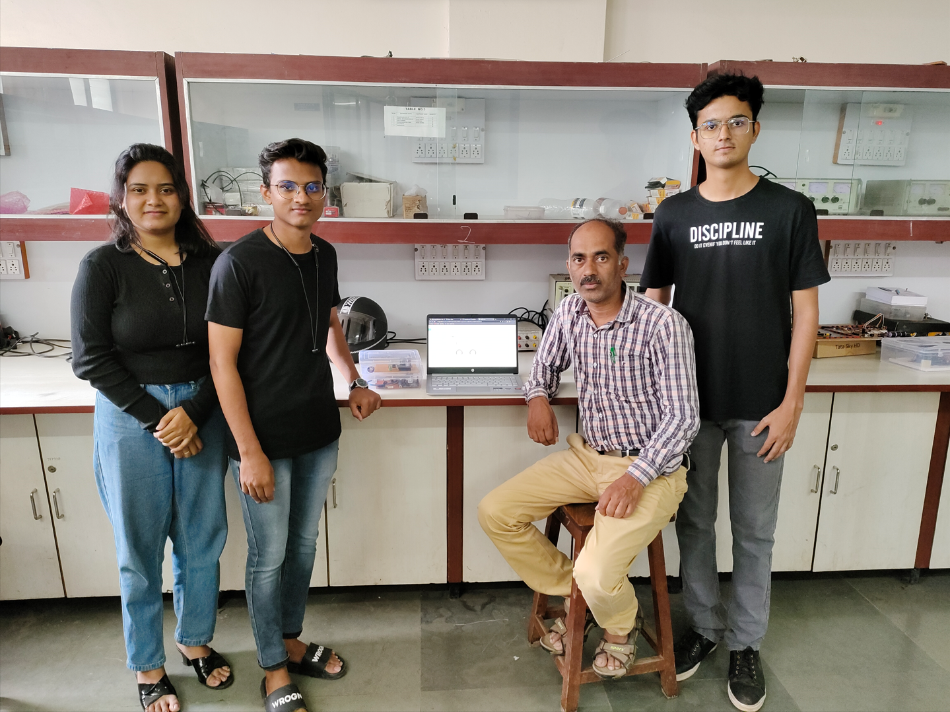

**Abstract:**

IoT-based coal mine monitoring and alerting system using Arduino as a tool to enhance the safety and efficiency of mining operations. The methods employed involve installing sensors on a wearable device to capture crucial parameters such as temperature, humidity, gas levels, and flame. These sensors are connected to Arduino boards, enabling data collection and transmission via ZigBee technology to a central hub or gateway. The data is then analyzed and monitored in real time. The results of the study demonstrate that the wearable device is configured to send alerts to the control unit when any of the parameters exceed pre-set thresholds. A piezoelectric buzzer is employed to promptly alert the control unit, enabling swift response and necessary actions to safeguard the workers. The significance of this study lies in the remote monitoring and management capabilities offered by the IoT-based system. It enables continuous monitoring of the mine environment and workers' safety, while also generating real-time alerts on potential hazards or issues. This aids mining companies in accident identification and prevention, ultimately enhancing the overall safety and efficiency of mining operations.

**Keywords**: IoT-based system, coal mine monitoring, Arduino, safety, efficiency, wearable device, real-time alerts, remote monitoring.

**Major Hardware Components Used:**

Arduino Nano, Node MCU, Zigbee, Sensors.

**Software Used:**

Open Source IoT Platform, Blynk.

**Guide:**

Prof. K. R. Biradar

**Name of Students:**

1. Pranav Sonar

2. Pooja Thakur

3. Chandrashekhar Yemul